**WILEY CANYON SCHOOL**



**PARENT AND STUDENT**

**HANDBOOK**

**2023-2024**

# WILEY CANYON ELEMENTARY SCHOOL

**24240 LA GLORITA CIRCLE**

**NEWHALL, CALIFORNIA 91321**

## PHONE: (661) 291-4030 FAX: (661) 291-4031

[**www.wileycanyonelementary.com**](http://www.wileycanyonelementary.com)

August 10, 2023

Dear Parent(s) of Wiley Canyon Student(s):

At Wiley Canyon, we are “committed to providing a safe and inclusive educational environment that empowers students to take risks, own their learning, collaborate with peers, and become well-rounded responsible individuals who aspire to achieve their fullest potential.”

We believe:

* Wiley Canyon is a school where learning and academic achievement is a partnership among students, staff, parents, and the community.
* Students experience success in a positive, healthy environment with a highly-qualified staff who model respect, patience, and compassion.
* Our students are respectful, responsible scholars who take ownership of their learning.
* Our curriculum is standards-based and ever-changing to accommodate the needs of our student population.
* Staff utilizes a variety of teaching strategies and incorporates technology and the arts across the curriculum.
* Intervention and enrichment opportunities exist and are essential components to a well-rounded educational experience.
* Students discover an inner passion for learning by believing in their ability to achieve personal goals while striving to reach their highest potential.

To be successful, we will need to support our students in the development of self-discipline and individual responsibility. Students are expected to follow our school-wide behavior expectations and guidelines contained in the Wiley Canyon Student Handbook. It is important that parents, school staff, and students work together to maintain a positive educational atmosphere. The staff needs the support of parents in modeling and promoting acceptable behavior. Our goal is for each student to learn to be responsible for his or her own actions. Our site will continue to use Positive Behavior Intervention and Support (PBIS) practices to encourage our students to develop and strengthen their scholarly traits.

Thank you for taking the time to read and discuss the Wiley Canyon Handbook with your child. If you have any questions, don’t hesitate to contact us.

With your continued support, the school year will be a positive and inspiring experience for the scholars at Wiley Canyon School. We look forward to partnering with you to support our students.

Sincerely,

Marguerite Armstrong

Principal

Sarah Johnson

Assistant Principal

**WELCOME TO WILEY CANYON ELEMENTARY SCHOOL**

We want to welcome you to our school and thank you for being an active member of our school community! We look forward to another successful year with the BEST students, staff, and parents in the district. We are open to your suggestions and welcome the opinions and help of our parents and community members as we learn and grow together.

**GENERAL PROCEDURES**

**TIME OF STUDENT ARRIVAL**

Our school gates open at ***7:45 am.***  The playground has NO adult supervision before ***7:45 am.***  In order to continually maintain a safe and orderly environment at school, children may not be on the campus unsupervised. Therefore, it is important that students do not arrive before that time. Breakfast is served from 7:45 am to 8:15 am each day in the cafeteria. Students are expected to be in line and ready to enter their classrooms when the first bell rings at 8:20 am. School begins at 8:25 am.

*For the safety and protection of all students,*

**parents must have valid ID and check in at the office**

*to be allowed on campus.*

**ABSENCES AND TARDIES**

Research shows that ***daily school attendance significantly impacts student achievement.*** Children cannot learn if they are not in school. We ask for your support in emphasizing with your children the importance of regular school attendance and being on time each day. Children 6 to 18 must attend school every day.

Wiley Canyon School practices a “protect our children” program. All children not present at school are accounted for daily. We ask parents to follow this procedure:

● Please notify the school (661-291-4030) between the hours of 7:30 and 9:30 a.m. in the morning that your child will be absent or late. State the child’s name, teacher’s name and reason for absence.

● If your child is late, please have him/her go to the office for a tardy pass.

● Once the attendance records are checked each morning, parents of any child not accounted for will be contacted to clear the absence.

● Teachers encourage children to arrive at school on time, ready for instruction. Parents can help by sending children off to school with a healthy breakfast or remind children to enjoy a free breakfast in the cafeteria. Food feeds our brain!

● Vacations are ***unexcused*** absences. Please plan vacations during non-school days.

● If you wish to pick up homework for your child for an absence, please call the office between 7:30 and 9:30 am the day that homework is requested so the teacher can gather appropriate materials.

**INDEPENDENT STUDIES**

If your child must be taken out of school for ***unavoidable*** personal reasons, parents may request a Short-Term Independent Study for the duration of 3-14 days. This is an option that parents may take advantage of which will help both the school and your child, however, no pupil may be required to participate. To qualify for independent study, students must be absent for a minimum of 3 days. Please contact the office with a ***minimum*** of one week's advance notice. Approval for this request is based on the student's ability to work independently and complete the assigned work. Students in grades K-3 are granted a maximum of 10 consecutive days for absence and students 4-6 are granted a maximum of 15 consecutive days for absence.

**SAFETY RULES FOR ARRIVAL / DISMISSAL**

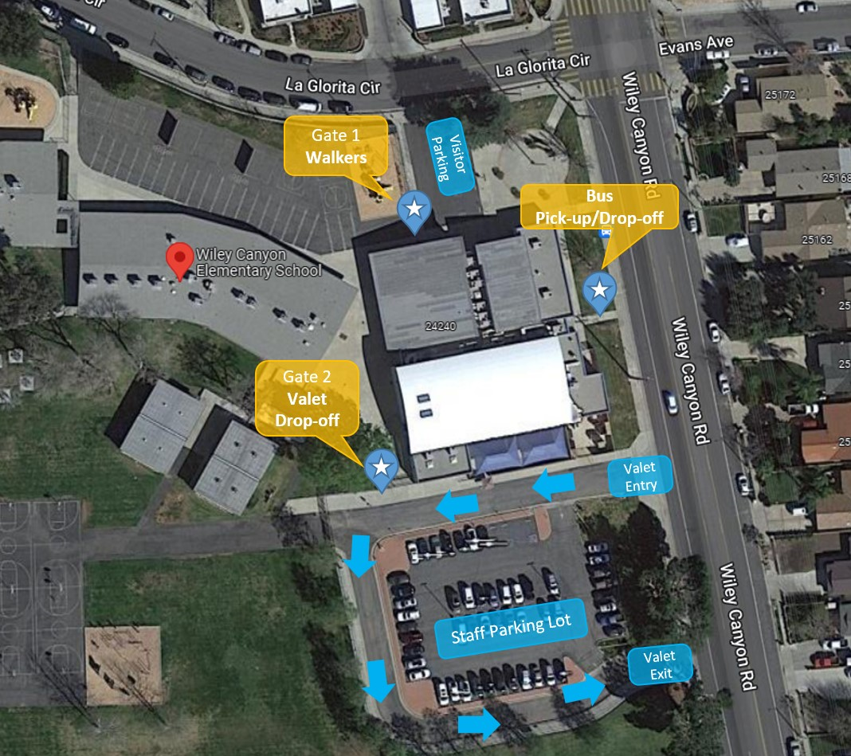

**CAR VALET (Wiley Canyon Road)**

1. Children may be dropped off or picked up at the valet line (off Wiley Canyon Road) starting at 7:45 a.m.

2. Children MAY NOT be dropped off or picked up in the STAFF Parking Lot. This lot is reserved for staff use only.

3. Please do NOT park on Wiley Canyon Road. This is a designated loading & unloading bus zone.

**4. U-turns are not permitted in front of the school and put students and parents in danger as they enter campus.**

**PLEASE HELP US KEEP OUR CHILDREN SAFE!**

**WALKING TO SCHOOL (La Glorita Circle)**

If your child is going to walk to and from school, please discuss the safest and most direct route and the approximate time the trip takes. Insist he/she cross

at corners and obey signals. Encourage your child to walk with a partner or group. School rules apply while traveling to and from school.

It is wise to discuss with each child the importance of refraining from conversation with strangers. A child should understand that under NO circumstances is he or she to accompany a stranger or enter an automobile without parents’ permission.

Personal property rights of others should be also stressed. Good citizenship is to be practiced both to and from school. School rules apply while traveling to and from school.

**BICYCLES**

In order to ensure a higher level of safety for pupils who ride bicycles to and from school, it is the policy of the Newhall School District that pupils will be required to wear bicycle helmets. Only helmets which display a Snell (Snell Memorial Foundation) and/or CPSC (Consumer Product Safety Commission) approval sticker are acceptable.

Students in grades 4-6 have the privilege of riding their bicycles to and from school as long as the following guidelines are obeyed.

1. ALL bikes are to be walked on

school grounds.

2. No child is to ride a bike through the parking lot during school hours.

3. Each bike MUST have a lock and chain.

4. ALL students are to stay away from the bike area during school hours, except during parking and exiting.

5. California Bicycle Safety Rules will

be enforced.

6. Bicycle helmets MUST be worn while traveling to and from school.

7. Any violation of these bicycle regulations at school or to and from school may be cause to deny the bike-riding privileges.

*Students in grades 1–3 may only ride bicycles if accompanied by an adult.*

Wiley Canyon School recommends that students do NOT use skateboards,skates, or scooters to get to school as there is no storage available on campus.

**Positive Behavior Interventions and Supports (PBIS)**

The purpose of Positive Behavior Interventions and Supports (PBIS) is to establish and maintain a climate at Wiley Canyon in which appropriate behavior is the norm. We will uphold consistent expectations and consequences for all students. Through PBIS, we will shape student behavior by explicitly teaching school wide expectations through modeling and positive reinforcement. As a school, we will collect data around behavior in order to provide tiered support to students most in need.

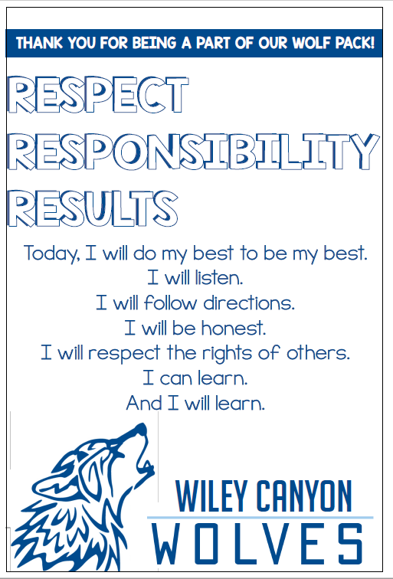

**SCHOOL BEHAVIOR EXPECTATIONS**

The matrix below outlines the specific school expectations that will be presented to students and enforced throughout the school year.

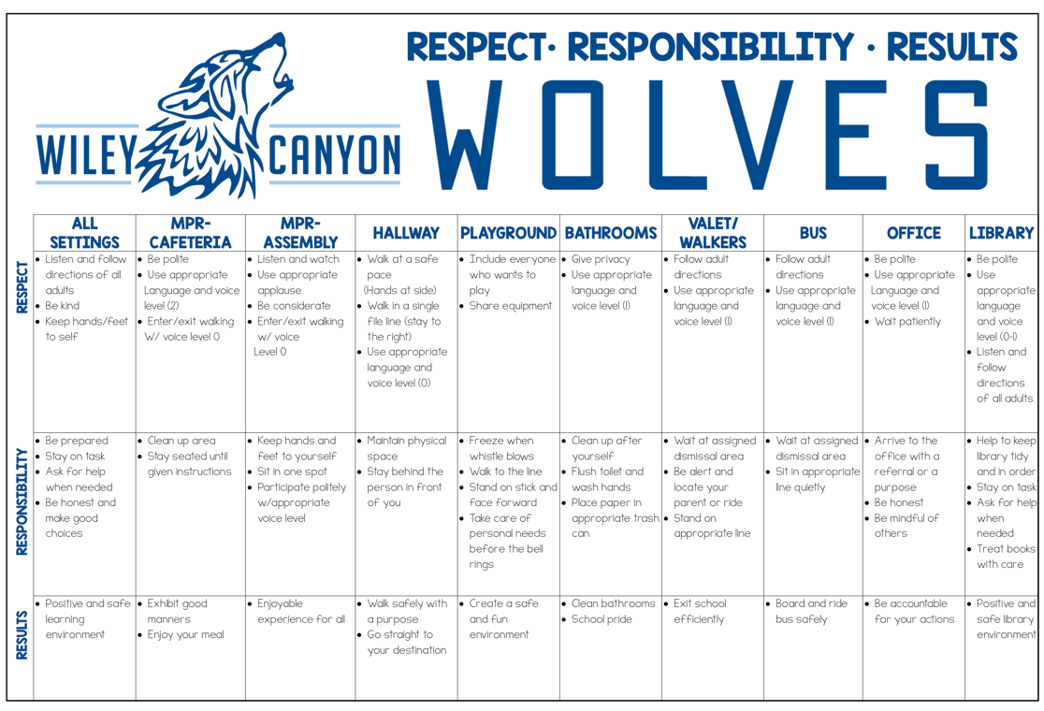

**DRESS AND GROOMING**

While on campus, or while attending any school sponsored event, pupils shall be dressed and groomed in a manner which does not distract or interfere with the educational environment. Parents have the primary responsibility for assuring that pupils are properly attired. The District desires to keep the school environment free from the harmful influence of groups which advocate substance abuse, violence, criminal activity, or disruptive behavior. The Board finds that regulations prohibiting pupils from wearing gang related apparel are necessary for the health and safety of the school environment. In recognition of this, the Governing Board has adopted this regulation relative to the dress and the appearance of pupils:

**BASIC DRESS GUIDELINES**

1. Closed toe shoes must be worn at all times, except for medical necessity. A substantial sole is required and an enclosed heel is strongly recommended. For example, strapless sandals are not acceptable. Wheels in shoes are not allowed on campus.

2. Extremely brief garments such as short shorts, halter tops, bare midriffs, tube tops, net tops, oversized tank tops, spaghetti straps, and plunging necklines (front and/or back) are not allowed.

3. Garments or jewelry with slogans or pictures promoting the use of drugs or alcohol, substance abuse, vandalism, graffiti, violence, or profanity will not be allowed.

4. Garments with suggestive, obscene, or sexually explicit statements or pictures will not be allowed.

5. Garments must be fitted. Pants must stay up at the waist without the use of a belt and/or suspenders.

6. Combat boots, combat type boots, or steel tipped shoes will not

be allowed.

7. Hair shall be clean and neatly groomed.

**CELL PHONES**

Cell phones and other technologies are allowed on campus, but, must ***be turned off and stored in back packs*** during academic hours. The school assumes **NO RESPONSIBILITY** in case of loss or theft. It is the student’s responsibility to have the phone completely turned off and inside a backpack (not on his/her person during school hours). Students must never use the cell phone during school hours. If cell phones are not used appropriately on campus, or if they are out during instruction, they will be removed from the student; the phone will be returned to a parent only.

**HEALTH AND MEDICATION**

If your child needs to take daily medication, it will be necessary to have a signed request from your doctor. This includes aspirin, throat lozenges and all other nonprescription medications. All medications will be kept in and dispensed by the school office.

Please contact the office if your student has casts, slings, stitches, or special supports as he/she must have an alternate recess/lunch setting. This is a precaution to protect the students from possible further injury.

**FOOD SERVICES**

A school breakfast and lunch program is provided for pupils. **ALL students qualify for FREE breakfast and lunch this school year.** Students may also bring a sack lunch from home. Cafeteria menus are provided one month in advance at https://scvschoolnutrition.org/.

**PICKING UP CHILDREN EARLY FROM SCHOOL**

If you want to pick up your child from school for an appointment or if you have any change in dismissal, please notify the office with a written note or email our office at **wc-office@newhallsd.com.** When emailing please be sure to write Wiley Canyon DISMISSAL in the subject line so our SPAM filter doesn’t reject your email. Be sure to include the child’s name, teacher, and REASON for early dismissal and time.

Please note: All changes to pick-up plans must be made prior to lunch recess, to avoid classroom interruptions.

Wiley Canyon School takes your child’s safety very seriously. If you need to send a representative other than a parent and if that person is NOT on your emergency card, please be sure to notify the school office IN WRITING.

FOR YOUR CHILD’S SAFETY, THE SCHOOL OFFICE CANNOT RELEASE A CHILD FOR ANY PERSON NOT LISTED (INCLUDING OLDER SIBLINGS) ON THEIR EMERGENCY CARD WITH A VERBAL REQUEST.

**SCHOOL BUSES**

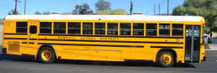

Bus drivers are responsible for the safety of all children who ride the bus. Any child who does not follow the driver’s instructions as well as the bus riding rules may lose his/her privilege to ride the bus.

**Transportation maybe contacted directly at 661-259-0033 ext. 707**

**AERIES PARENT PORTAL**

The Aeries Parent Portal is where you will find your child’s electronic school records including, **emergency contact information**, registration information, photo release, our school handbook, and report cards. The portal should be used to update your emergency contact information if anything changes.

**PARENT COMMUNICATION NOTICES**

Our District and school site utilize **Parent Square** as our primary source of communication. Messages will be sent home routinely during the school year, including weekly newsletters, flyers, surveys, etc. ***Please be sure to download the app to get up-to-date information as soon as it is sent out. Teachers also use Parent Square*** to keep families informed. This two-way communication system makes it easy to stay connected with families.

**LOST AND FOUND**

We urge parents to sew or mark children's names in coats, sweaters and other personal items. This will facilitate the return of lost garments and articles. If lunch pails are used, please have them marked also. Lost and Found items are located in the hallway near the office. Please check there from time to time for lost articles.

**VISITS TO THE SCHOOL** 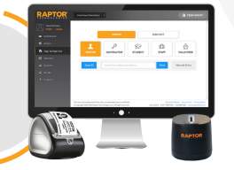

In order to maintain a safe and secure

environment for all children and adults at our school, any person who comes on school grounds must report immediately to the school office and log in with our Raptor visitor management system. This will require that visitors have a California issued identification

and receive a printed badge.

**CLASS INTERRUPTIONS**

The Newhall School District has adopted a policy which attempts to limit interruptions during instructional time. This policy recognizes the importance of providing pupils with sustained, uninterrupted instruction. We request your cooperation in scheduling, whenever possible, medical and dental appointments after school so that children will not miss instruction.

**CLASSROOM VISITATION BY PARENTS**

Parents are welcome to observe their children in the classroom. Please review the following guidelines for classroom observations:

1. All classroom visits are arranged through the school administrator at least two days prior to the planned visit.

2. You are asked to check in at the office and obtain a visitor's pass when you arrive so that we know you are here and may be of service to you.

3. Visitations are most effective after the first three weeks of school and should be limited to approximately fifteen minutes unless a longer period has been previously arranged with the child's teacher.

**REPORT CARDS/CONFERENCES**

Report cards are issued three times during the year and will be accessible through the Aeries Parent Portal. Parents will be invited to a parent/teacher conference twice during the school year. Also, parents may make an appointment to meet with their child’s teacher at any time, and we encourage this practice.

**VOLUNTEER PROGRAM**

Volunteering is an important way for parents to participate in their child’s education and gain a special awareness of how best to help their child at home. We encourage parents to work directly with our Room Parent Coordinator to sign-up to volunteer. For safety reasons, preschool age children are not permitted to accompany parents volunteering at school. If parents are unable to find child care, the teacher may have tasks that can be completed at home.

**Wiley Canyon PTA**

Wiley Canyon PTA is an active and enthusiastic group of parents whose primary purpose is to support, enhance, and enrich the educational experience of children at Wiley Canyon School. Your membership and participation in Wiley Canyon’s Parent Teacher Association is needed, encouraged, and warmly welcomed.

**LIBRARY**

Wiley Canyon School has a library and school library/media technician to service the educational and recreational needs of the school community. Each class will attend library orientation at the opening of the school year and classes will have a regular time to visit the library to check out books to support our young readers.

**Wiley Canyon SCHOOL SITE COUNCIL**

Wiley Canyon School Site Council is composed of parent/community members and members of the school staff elected by their representative groups. Functioning in an advisory capacity, they assist in planning and assessing Wiley Canyon’s programs and resources and allocating site fund